**E-commerce Sales Performance Analysis Report**

**Business Problem and Objective**

The UK-based online retail store seeks an E-commerce Sales Performance Analysis leveraging its transaction data from December 2010 to December 2011. The store's primary concern is to **mitigate future revenue decline** and **achieve sustainable sales growth**.

The objective is to analyze Key Performance Indicators (KPIs) such as **Revenue**, **Customer Lifetime Value (CLV)**, and **Average Order Value (AOV)** across product categories, customer segments, and geographic regions. This analysis will isolate the policy factors (e.g., product mix, regional pricing) that most significantly influence high-value sales, culminating in clear, data-driven recommendations for policy adjustments required to increase sales and ensure year-over-year revenue stability.

The **primary objective** of this project is to analyze and track sales performance metrics to inform policy adjustments.

**Assumptions**

1. The business environment and customer purchasing behavior patterns will remain consistent with the 2010–2011 data period over the forecast horizon.
2. The store has not yet implemented any new sales policies or structural changes in direct response to the sales performance concerns raised in this problem statement.

**Hypotheses**

1. Products purchased in large quantities have low prices; therefore, the store should ensure low-priced products are highly available in stock.
2. Customers who purchase in large quantities also tend to return in large quantities.

## Research Questions

1. What was the **total revenue** for the entire 2010–2011 period, and what is the **month-over-month revenue trend**?
2. What is the **correlation** between the **Unit Price** and **Quantity** columns?
3. Which are the **top 10 countries** by **quantity of transactions returned**?
4. Which are the **top 10 countries** by the **quantity of products ordered**?
5. What is the **total order quantity** for the top 10 countries?
6. What **percentage of total sales** (by order quantity) do the top 10 countries account for?
7. Which are the **top 10 countries** that generated the **highest total revenue**?
8. Which are the **top 3 selling products** (by quantity) in each of the top 10 countries?
9. Which are the **overall top 10 customers** based on the **quantity of products purchased**?
10. Which are the **overall top 10 customers** based on the **quantity of products returned**?
11. Is there a relationship between customers who **purchase large quantities** and those who **return large quantities**?
12. Who are the **top 10 customers** in **each of the top 10 countries**, based on the quantity of products ordered?
13. Which month had the **highest number of sales** (based on the count of unique Invoice Numbers)?
14. Which month had the **lowest number of sales** (based on the count of unique Invoice Numbers), and what is the likely reason?
15. What is the **monthly quantity sold trend** for the top 10 countries?
16. Which are the **top 10 selling products** by quantity?
17. Are products with a **high unit price** generally sold in a **low quantity**?
18. When do most orders occur (**afternoon, evening, or night**), based on the count of unique Invoice Numbers?
19. What is the **Average Customer Lifetime Value (CLV)** based on the 2010-2011 data?
20. Who are the **top 10 customers** with the **highest CLV** based on the 2010-2011 data?
21. How does the **Average Order Value (AOV)** change **month-over-month**, and what is the **AOV for the entire period**?
22. **Analysis and Visualizations**

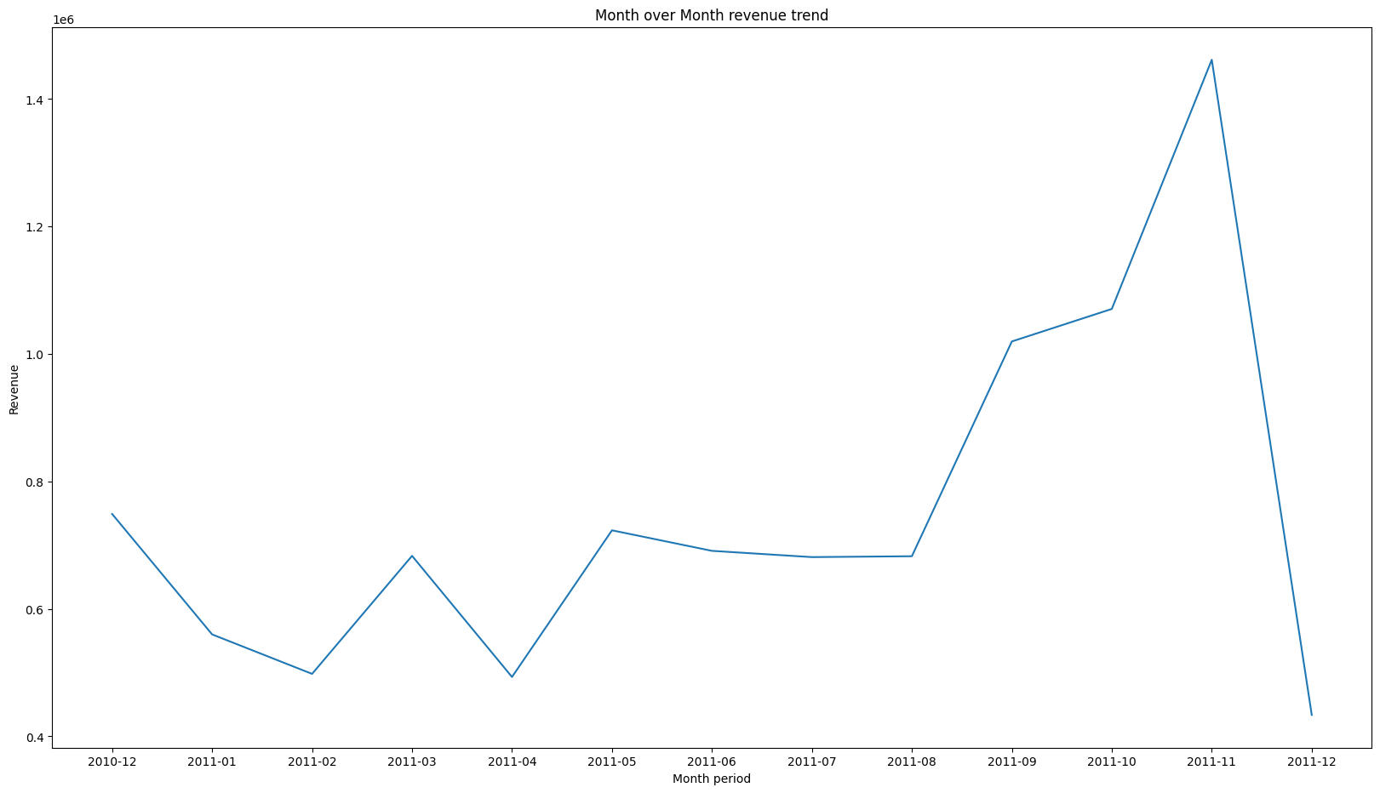

The line chart illustrates the monthly revenue performance across the 2010–2011 period.

* **Peak Performance:** Revenue trended upward, reaching its peak in **November 2011** , which had the highest sales volume.
* **Sustained Growth:** A period of sustained growth is evident, with sales consistently rising from **April 2011** (the 4th month) until the peak in November.
* **Data Caveat (December):** The chart shows a sharp drop in **December 2011**, reaching the lowest point on the line. This drop is artificially steep because the dataset only includes sales data for the **first nine days of December**.
* **Trough Performance:** When only full months are considered, the month with the **lowest revenue** was **February 2011**

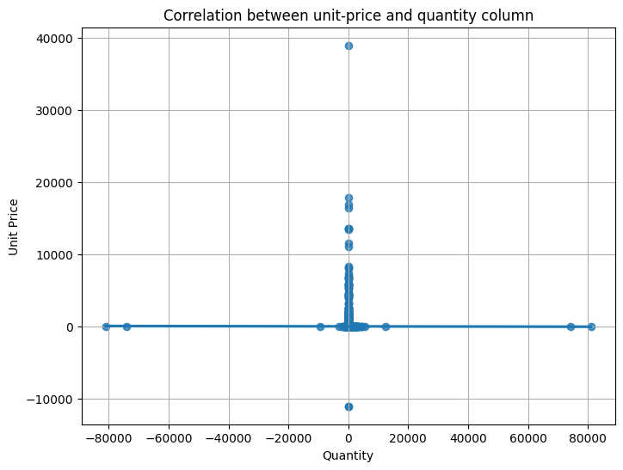

As illustrated in the scatter plot, the data points for **Quantity** and **Unit Price** display a **negligible correlation**, indicating that these two variables are **linearly independent**

The *Unit Price* and the *Quantity* are linearly independent so it is wrong to say that “The products bought in large quantity have low prices”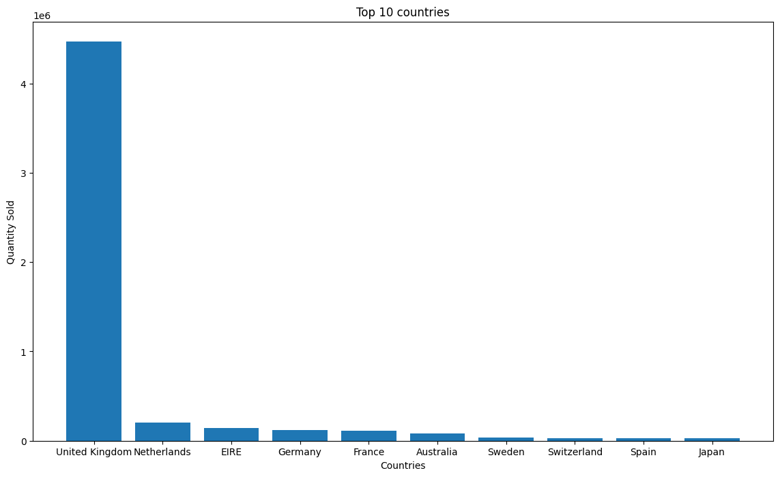

Above bar graph shows the Top 10 countries based on number of quantity sold.

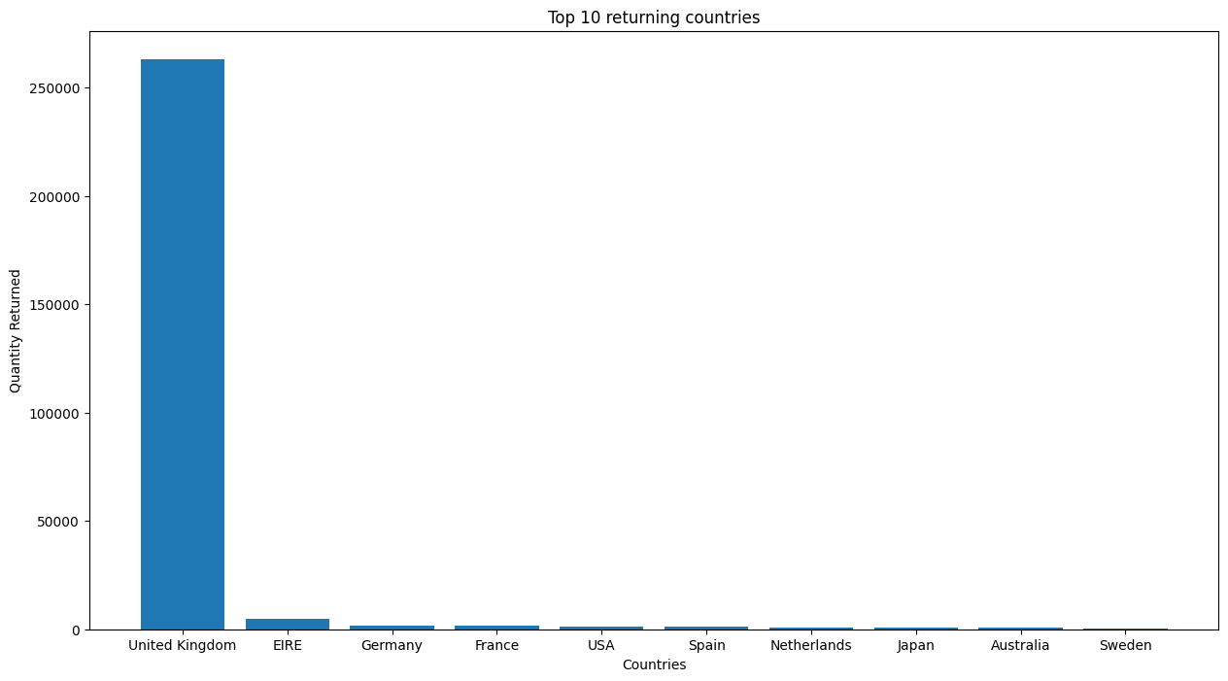

The visualization identifies the **top 10 countries exhibiting the highest volume of product returns**.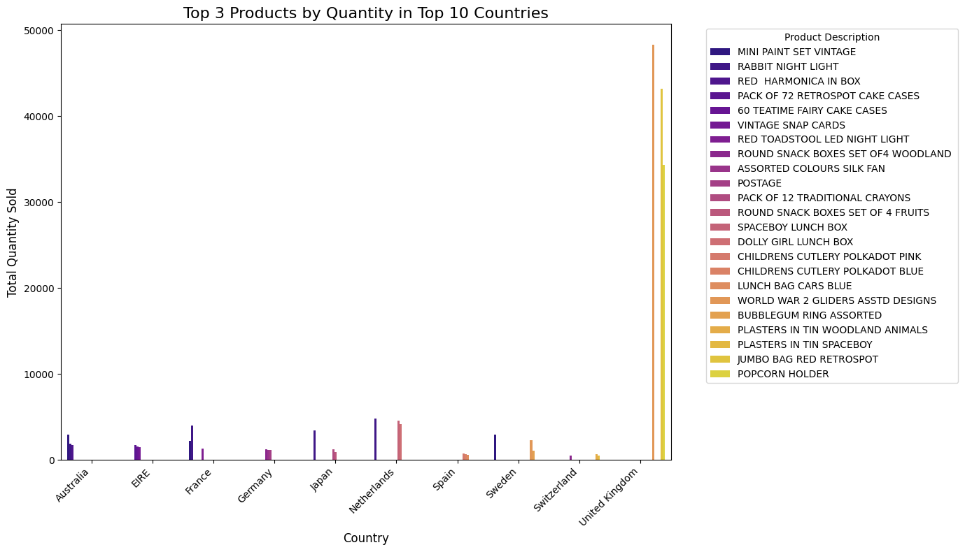

This visualization illustrates the **Top 3 selling products (by quantity)** for each of the top 10 countries.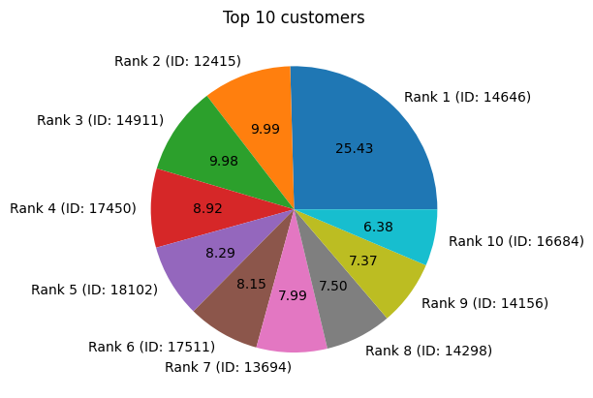

The pie chart displays the **top 10 customers, identified by Customer ID**, ranked by the **quantity of products ordered**.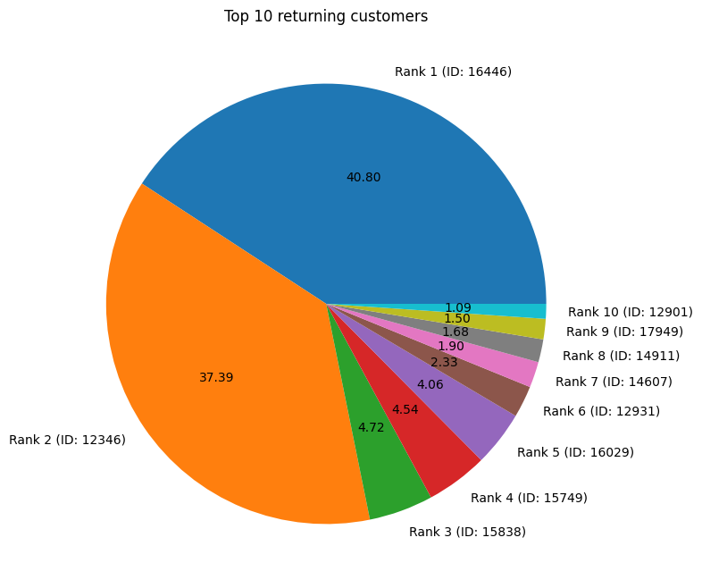

This visualization identifies the **Top 10 customers based on the total quantity of products returned**.

It is a **notable finding** that the **highest-volume purchasers** are distinct from the **highest-volume returners**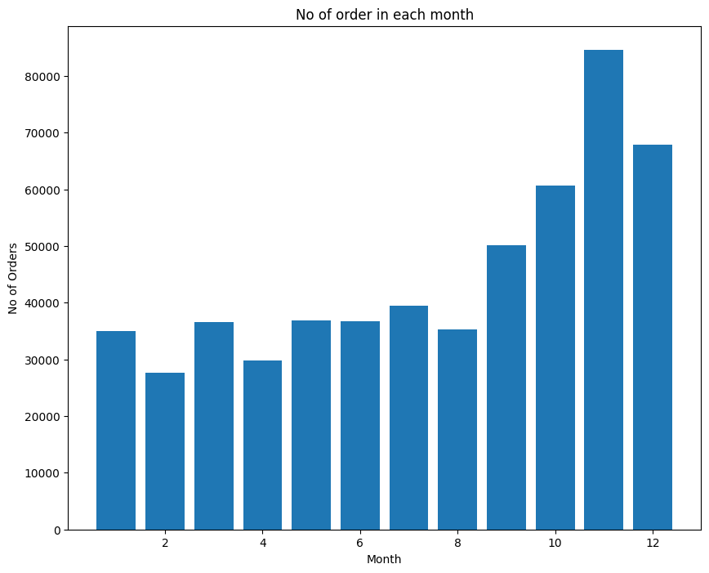

The visualization presents the **monthly order volume**, showing the frequency of transactions over the period.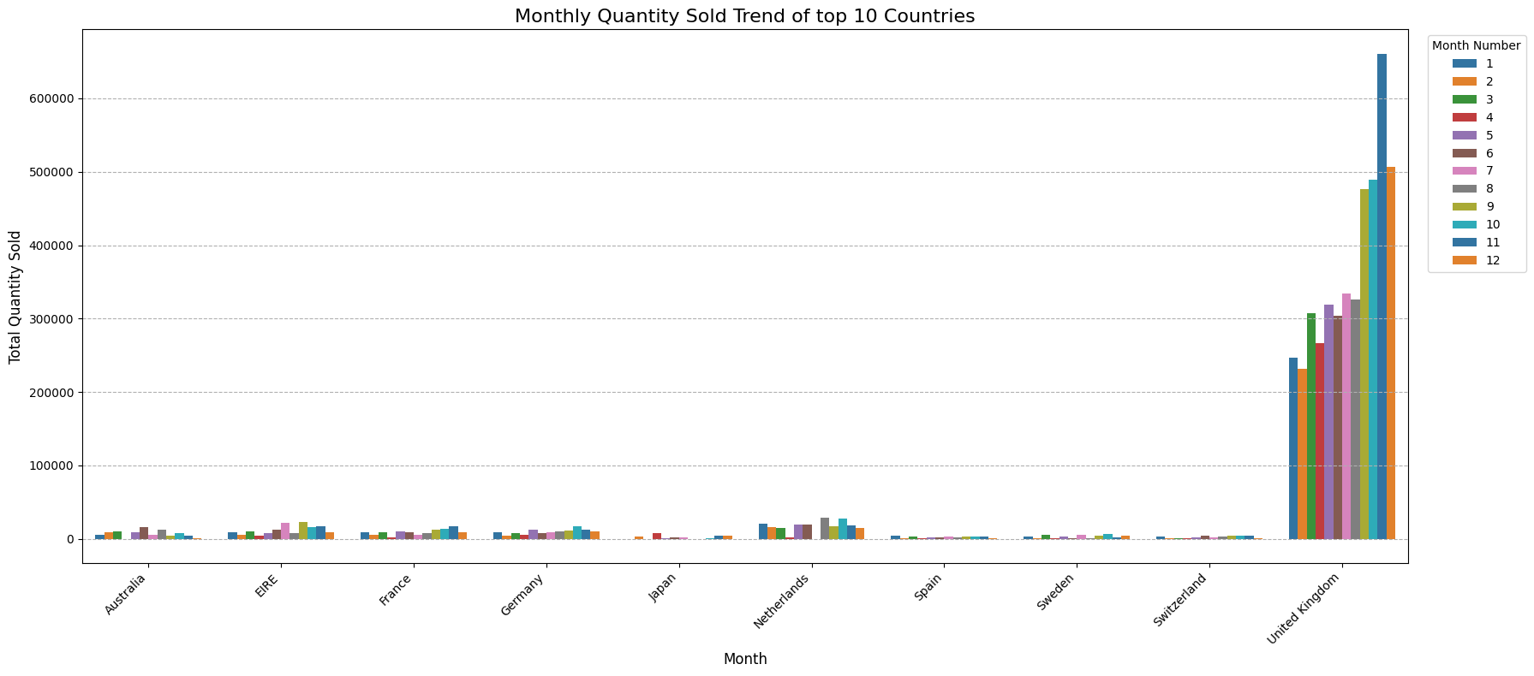

The graph presents the **distribution of sales volume** across all months for the top ten performing countries.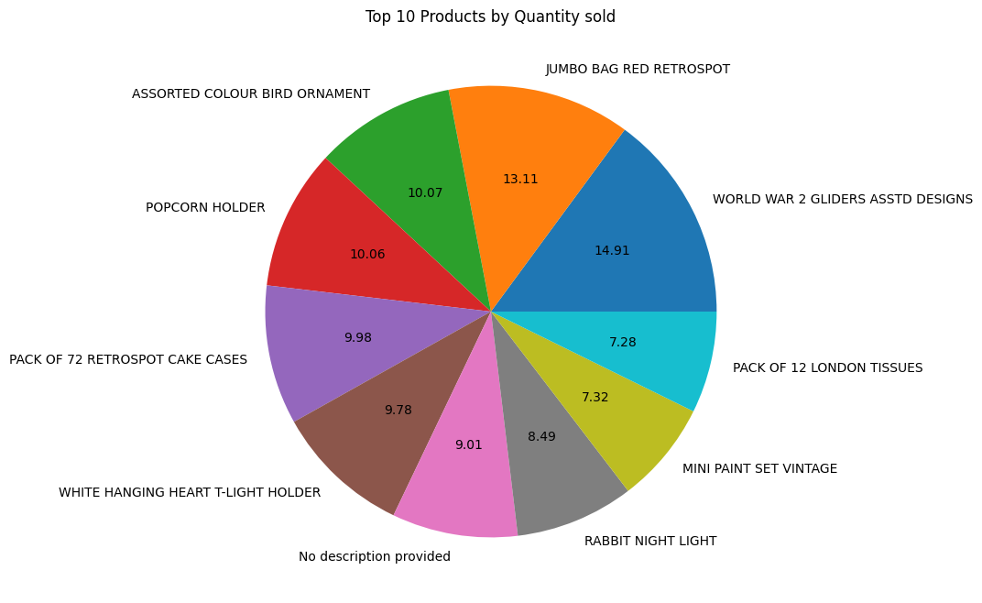

The pie chart displays the **Top 10 products** ranked by **sales quantity**.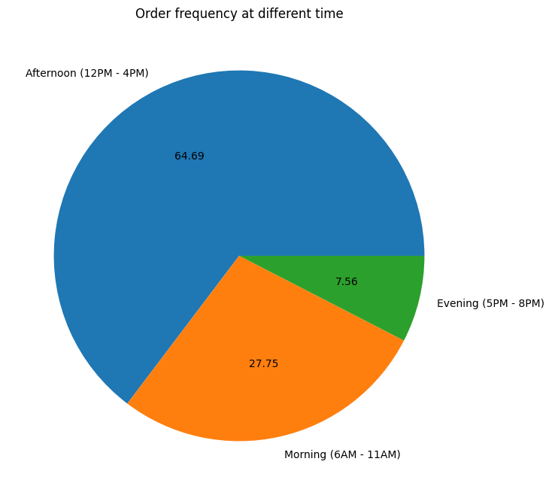

• The pie chart shows the **distribution of orders** across different time periods (Morning, Afternoon, Evening).

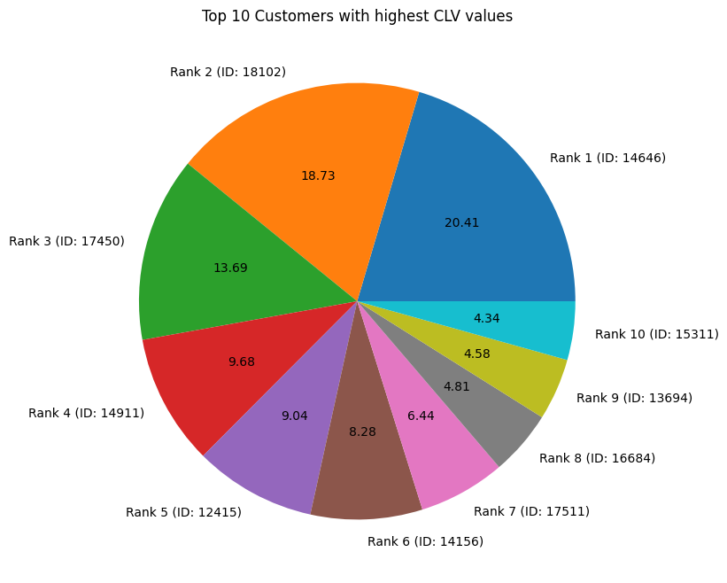

The pie chart displays the **Customer IDs** of the **top 10 customers** ranked by their **highest Customer Lifetime Value (CLV)**.

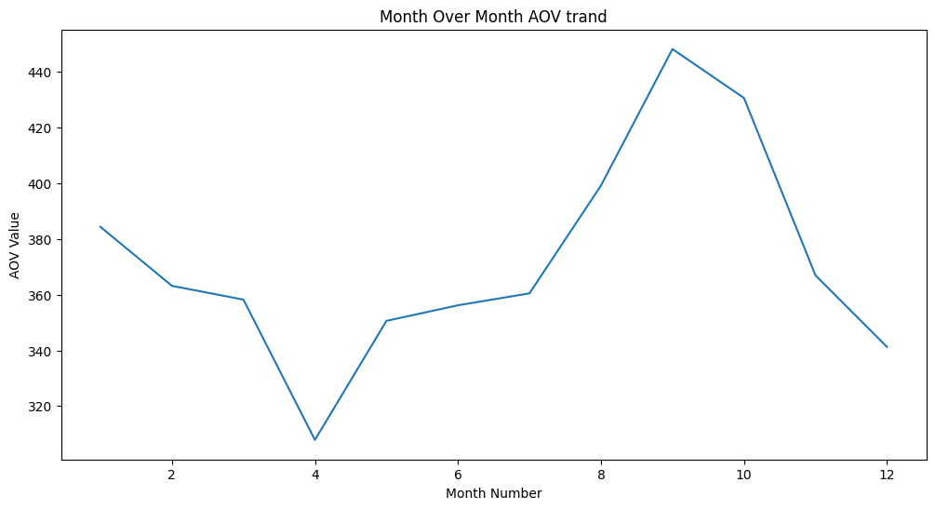

The line chart displays the **month-over-month trend** for the **Average Order Value (AOV)**.

**Key Insights and Analysis Summary**

**Sales and Pricing**

* **Correlation of Price and Quantity:** The unit price and the quantity sold columns have **almost no direct relationship**. The correlation value of **−0.0013 is extremely weak**, indicating that the hypothesis that large-quantity products have low prices is not supported by the data.
* **Top Markets:** The top 5 countries that purchase the most products (by quantity) are the **exact same** top 5 countries that generate the most money (total revenue).

**Geographic Performance**

* **USA's High Return Problem:** The **USA** is not one of the top 10 countries in terms of sales quantity, but it is the **5th country** with the highest quantity of returned products, indicating a worrying returns situation.
* **Netherlands' Good Balance:** The **Netherlands** is performing well. It is the **2nd country** in terms of product quantity sold but only the **7th** in terms of product quantity returned, representing a satisfying balance.

**Seasonal Trends and Operations**

* **Peak and Trough Months:** **November** has the highest sales volume (best month), primarily due to the **holiday shopping season** (Black Friday and Christmas gift buying). **February** has the lowest number of orders (worst month), likely caused by the **post-holiday spending slowdown** as customers financially recover.
* **Peak Order Time:** The afternoon (**12:00 PM to 4:00 PM**) is the busiest time, accounting for **65%** of all orders. Orders occur throughout a 14-hour window, starting at 6:00 AM and ending at 8:00 PM.

**Key Performance Indicators (KPIs)**

* **Average Order Value (AOV):** The typical amount spent in a single order is **$439.29**.
* **Average Customer Lifetime Value (CLV):** The average amount of revenue a single customer is expected to bring in is **$2,229.08**. This is based on a total revenue of **$9,747,747.93** from **4,373** unique customers.

**Data-Driven Recommendations**

1. **Prioritize Top Markets:** The store should heavily focus its efforts on the **top 10 ordering countries**, as they are responsible for a massive **97.4%** of the total product quantity sold.
2. **Inventory Management Strategy:** The store must ensure it has **high stock levels in November** to capitalize on peak sales but can reduce stock for the slower months of **February and March**.
3. **Optimize Peak Operating Hours:** Since the **afternoon (12:00 PM to 4:00 PM)** accounts for **65% of all orders**, the online store must ensure it is **fully operational and active** (customer service, site speed, inventory updates) during this peak period.
4. **Targeted AOV Campaigns:** The average AOV for all months is lower than the overall average of $439.29, except for September (at $448.23). This indicates that the store's campaign efforts were highly successful in September. Conversely, **April** has the **lowest AOV** ($307.84) and requires focused intervention.
5. **Focus on Q1/Q2 Sales Growth:** The store should concentrate on **increasing sales in the 2nd, 3rd, and 4th months (February, March, April)** by implementing strategies such as targeted advertising, price adjustments, and promotional offers to counter the post-holiday slump and low AOV.